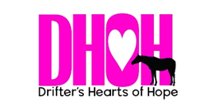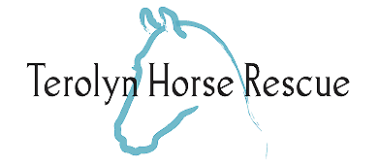
2022 SUMMER HOEDOWN
July 9th, 4-9pm
Sponsorship Opportunity
Hosted by Drifter’s Hearts of Hope AND Terolyn Horse Rescue!
Drifter’s Hearts of Hope is excited to announce that we will be throwing a summer hoedown alongside our partner rescue, Terolyn Horse Rescue! There will be live music, dancing, a mechanical bull, a bouncy house, both silent and live auction items, and more. Alcohol will be provided and, of course, there will be plenty of food! All proceeds will go directly to saving and rehabilitating horses in danger of entering the slaughter pipeline. Between the two rescues, we’ve helped save over 1,000 horses and we know we never could have done this without our amazing community! We are looking for sponsors to help us make this event a success and we are hoping you share our passion.
Your $1,500 sponsorship will include:
Banner of any size (provided by sponsor) will be hung by the stage
· Social Media Shoutouts
· Company Logo listed on Ticket Sales Site
· Company Website Link shared on both rescue’s Hoedown landing pages
· Emcee shoutouts during the event
· Sponsorship includes 4 complimentary tickets
☐YES! I Would love to sponsor Drifter’s Hearts of Hope and Terolyn Horse Rescue’s Hoedown!
Please make checks payable to DHOH and mail to:
Drifter’s Hearts of Hope
P.O. Box 888
Franktown, CO 80116
PLEASE EMAIL YOUR LOGO AND WEBSITE LINK TO INFO@DRIFTERSHEARTSOFHOPE.ORG AS WELL AS A FEW SENTENCES ABOUT YOUR COMPANY FOR ADVERTISEMENT AT THE EVENT. LET’S COORDINATE THE PICKUP AND/OR DROP OFF OF YOUR BANNER FOR THE EVENT AS WELL. WE ARE EXCITED TO HAVE YOU ON BOARD - THANK YOU!
DRIFTER’S HEARTS OF HOPE | 9555 DEERFIELD ROAD FRANKTOWN, CO 80116 | 303-521-5726
TEROLYN HORSE RESCUE | 47480 COUNTY RD 29 ELIZABETH, CO 80107 | 303-243-1147

