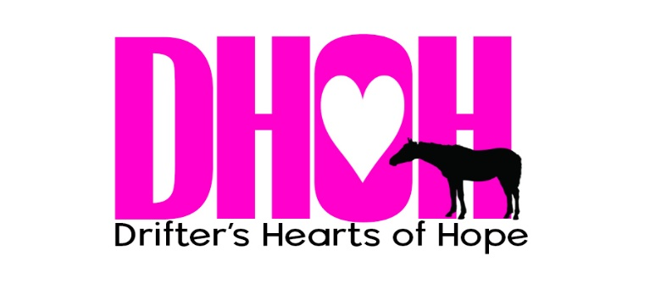

EQUINE ADOPTION APPLICATION
Drifter’s Hearts of Hope requires that this application be completed in full and submitted prior to the approval of adoption of any equine. Submission of an application does not guarantee adoption of any animal to any person regardless of the date of submission, previous conversations with Drifter’s Hearts of Hope staff or representatives, or previous knowledge of the animal. Drifter’s Hearts of Hope reserves the right to place animals in its care into adoptive homes in its sole and absolute discretion.

The adoption application is a part of the adoption process. Additional steps may be required for approval. All adopters must be 18 years of age or older. It is understood that adults may wish to adopt for persons under the age of 18. If the adoption is approved, the adult will be fully responsible for care of the adopted equine.

Please return your completed application via email to info@driftersheartsofhope.org.

Personal Information
Full Name: |  |  | Date of Birth:

Address:
City: | County: |  | State: |  | Zip:
Mailing Address (If different form above)
Address:
City: | County: |  | State: |  | Zip:
Driver’s License Information |  |  | State: |  | #:
Cell Phone: | Home Phone: |  | Email:
What other pets or livestock do you have?:
Do you, or anyone you plan to allow to ride your horse, weigh above 250 pounds? Yes No
*Please note, most horses can comfortably carry up to 250lbs (including tack). Riders weighing more than 250lbs will be best suited to adopting draft or draft-cross horses.
Have you ever been issued a citation, warning or been convicted of animal cruelty? Yes No
….
Equine Experience
What is your riding experience/equine experience?
Beginners: Rider is new around equines. Comfortable riding at a walk.
Advanced Beginners: Comfortable riding at a walk, and trot. Some experience with faster gaits.
Intermediate: Comfortable at all gaits, can handle equines in various situations and environments
Advanced: Comfortable handling difficult equines in various situations and environments.
Trainer: Has previous experience training equines or experience handling green equines.
Have you ever owned an Equine? Yes No

What style of riding or driving do you practice?
Are you working with a trainer? Yes No If yes, please provide your trainer’s name:
What to you intend to use this horse for?
Facility or Boarding Information
Will the Equine be stabled on your property of boarded out?
If kept on your property:
If you are a first-time owner, who will be helping you learn to keep horses properly, and be available during emergencies for help?
How many acres will the equine have access to?
What Kind of Shelter do you have (Barn/Stalls, loafing sheds, windbreaks, etc.?
What kind of fencing do you have?
What is the total number of equines on the property?
If the equine is boarded on someone else’s property:
Name of Boarding Stable: |  |  |  | Owner:
Address:
Have you boarded a equine at this facility before: Yes No

Additional Questions
Is there a specific equine you want to adopt? Yes No
If so, please describe the equine:
Will you accept an equine with a limitation? Yes No
Lameness: None Slight Rideable with special care Not rideable ( companion equine)
Behavioral: None Slight Needs confident handler Needs retraining
Health: None Minor needs (feed, etc.) Special needs (medications, blind, etc.)
What type of equine do you wish to adopt?
Experienced: Calm, gentle, minimal handling issues. Could be handled by child or beginner.
Inexperienced or Green: Has had inadequate training, but has good manners
Untrained: May never have been adequately handled or broke, or may be young.
References
It is our practice to contact references. These include personal acquaintances, veterinarians and farriers.
Reference #1
Name: |  | Phone:
Email:
Reference #2
Name: |  | Phone:
Email:

I attest that all of the information in this application is true to the best of my knowledge.
Signature of Applicant: | Date:

