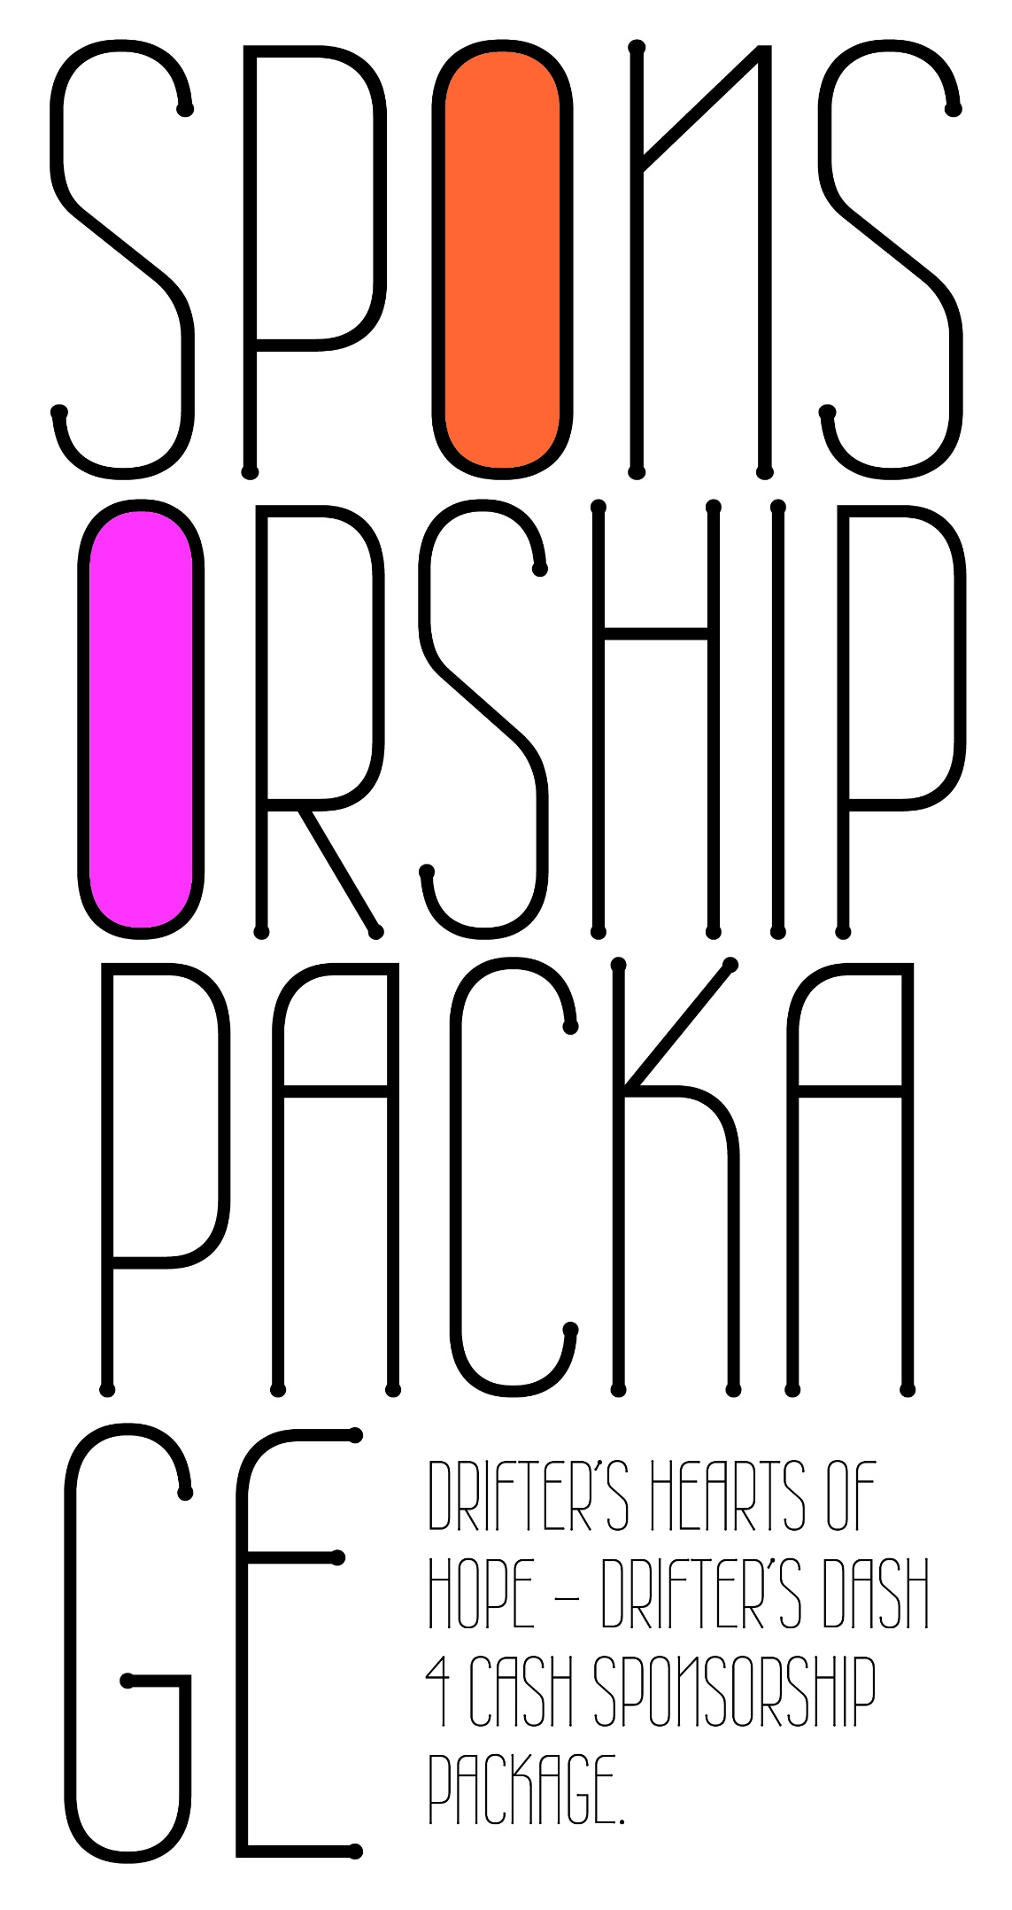
 | 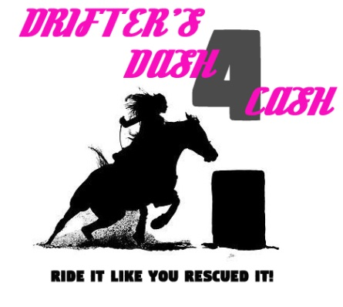 |  |  |  | 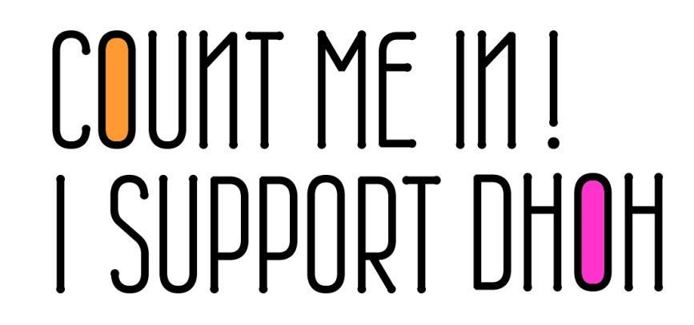
Sponsor Name
Contact Person
Address
Phone
Email
Sponsorship Level |  |  | Title Sponsor |  |  |  |  |  | _____ $1000
 |  |  | High Point Prize Bears Name, Banner Placement in Arena, Vendor Booth, Banner on Barrels, Event to be “Presented by” Title Sponsor
 |  |  | General Sponsor |  |  |  |  |  | _____ $250
 |  |  | Division will be “Presented by” Sponsor, Banner Placement in Arena, Vendor Booth
 |  |  | Basic Sponsor |  |  |  |  |  | _____ $50-$200
 |  |  | Banner Placement in Arena, Vendor Booth
 |  |  | Ride A Buck |  |  |  |  |  | _____ $250
 |  |  | Division will be “Presented by” Sponsor, Banner Placement in Arena, Vendor Booth
 |  |  | Stick Horse |  |  |  |  |  | _____ $250
 |  |  | Division will be “Presented by” Sponsor, Banner Placement in Arena, Vendor Booth
 |  |  |  |  |  | Total |  |  | $_______
Payment Method |  |  |  | Please make checks payable to DHOH and mail to:
 |  |  |  | Drifter’s Hearts of Hope
 |  |  |  | Attention: Drifter’s Dash 4 Cash
 |  |  |  | P.O. Box 888, Franktown, CO 80116
 |  | Credit Card # _ _ _ _ _ _ _ _ _ _ _ _ _ _ _ _ _ _ _ _ _ _ _ _ _ |  |  |  |  |  |  |  | Exp. Date _ _ _ _ _ _
 |  | Billing Address _ _ _ _ _ _ _ _ _ _ _ _ _ _ _ _ _ _ _ _ _ _ _ _ _ _ _ _ _ _ _ _ _ _ _ _ _
 |  | Please pay by check, if possible, so we can avoid credit card processing fees.
EMAIL YOUR LOGO ARTWORK TO INFO@DRIFTERSHEARTSOFHOPE.ORG
Preferably a vector art eps file with no background, or high resolution logo (300 dpi) jpg, tif, or pdf.
Please call Andrea at 720.300.0723 if you have questions or need help regarding logo artwork.
LOGO ART DUE JULY 18th

 | 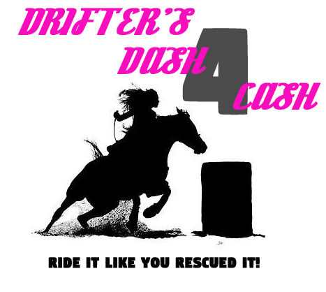 ​
 | "Drifter’s Dash 4 Cash" is a Gymkhana Horse show brought to you by Drifter's Hearts of Hope. Not only does your participation help raise money to save horses...it also helps empower special needs youth to save more! |  |  |  |  |  | We are dedicated to empowering children with special needs to rescue slaughter-bound horses. Our mission is to give these kids the opportunity to give back to the community, through the courageous effort of giving horses a second chance at life.
 | Casey Jones Park -4189 State Highway 86; Elizabeth, Colorado 80107 The show will start promptly at 8am on August 11th with the gates opening at 6:30am |  |  |  |  |  | You, your friends, local businesses, fellow horse rescuers, and anyone who just loves horses
- Entries are available online at www.driftersheartsofhope.org
- Cost is $10 per class
- High Point and Division Buckle Prizes
- Food Truck On-Site.
- Vendor booths for local horse products & Colorado businesses available at event.

